Project Design Phase-II
Data Flow Diagram & User Stories

Date | 13 July 2026
Team ID
Project Name | DARSHAN EASE (MERN Stack)
Maximum Marks | 4 Marks

Data Flow Diagram:
A Data Flow Diagram (DFD) is a traditional visual representation of the information flows within a system. A neat and clear DFD can depict the right amount of the system requirement graphically. It shows how data enters and leaves the system, what changes the information, and where data is stored.
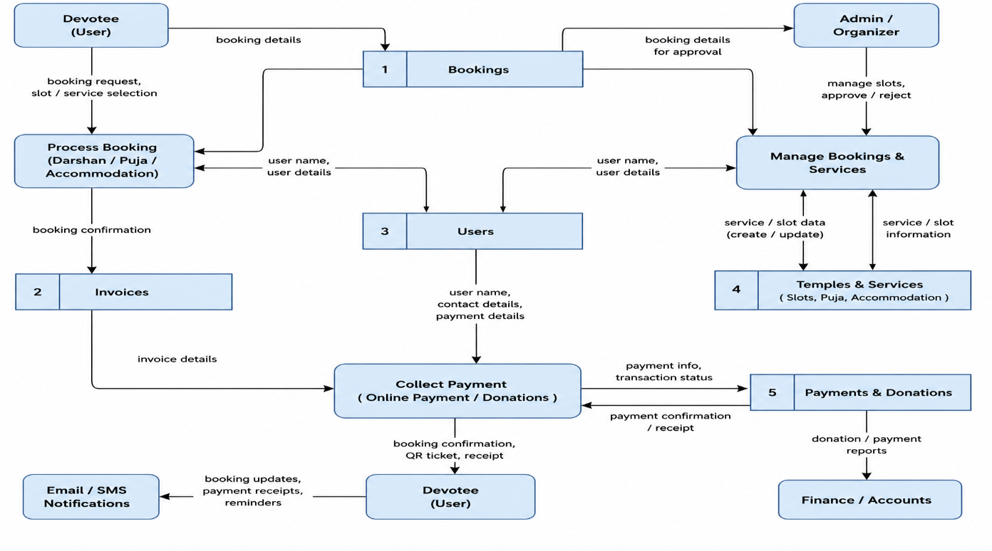

User Stories

User Type | Functional Requirement (Epic) | User Story Number | User Story / Task | Acceptance Criteria | Priority | Release
Customer (Web User) | Registration | USN-1 | As a user, I can register by providing my name, email, and password. | User account is created successfully. | High | Sprint-1
Customer (Web User) | Login | USN-2 | As a user, I can log in using my email and password. | User is redirected to the dashboard after successful login. | High | Sprint-1
Customer (Web User) | Temple Browsing | USN-3 | As a user, I can browse available temples. | Temple list is displayed with details. | High | Sprint-1
Customer (Web User) | Temple Search | USN-4 | As a user, I can search temples by name or location. | Matching temples are displayed. | Medium | Sprint-1
Customer (Web User) | Darshan Booking | USN-5 | As a user, I can book an available darshan slot. | Booking is confirmed and stored successfully. | High | Sprint-2
Customer (Web User) | Special Puja | USN-6 | As a user, I can request a Special Puja service. | Request is submitted with Pending status. | High | Sprint-2
Customer (Web User) | Accommodation | USN-7 | As a user, I can book Dharamshala accommodation. | Booking request is submitted with Pending status. | High | Sprint-2
Customer (Web User) | Donations | USN-8 | As a user, I can donate to a temple online. | Donation request is recorded successfully. | High | Sprint-3
Customer (Web User) | Anonymous Donation | USN-9 | As a user, I can donate anonymously. | Admin sees "Anonymous Devotee" instead of user name. | Medium | Sprint-3
Customer (Web User) | Booking History | USN-10 | As a user, I can view my booking history. | All previous bookings are displayed. | High | Sprint-3
Customer (Web User) | Donation History | USN-11 | As a user, I can view my donation history. | Donation records and status are displayed. | Medium | Sprint-3
Customer (Web User) | QR Ticket | USN-12 | As a user, I can view my QR ticket after booking approval. | QR code is displayed only for approved bookings. | High | Sprint-3
Customer (Web User) | Cancel Booking | USN-13 | As a user, I can cancel a pending booking request. | Booking status changes to Cancelled. | Medium | Sprint-3
Administrator | Booking Management | USN-14 | As an admin, I can approve or reject Special Puja requests. | Booking status updates correctly. | High | Sprint-4
Administrator | Accommodation Management | USN-15 | As an admin, I can approve or reject accommodation requests. | Booking status updates correctly. | High | Sprint-4
Administrator | Donation Management | USN-16 | As an admin, I can approve or reject donations. | Donation status updates to SUCCESS or FAILED. | High | Sprint-4
Administrator | Slot Management | USN-17 | As an admin, I can update darshan slot availability and capacity. | Slot details are updated successfully. | High | Sprint-4
Administrator | Dashboard | USN-18 | As an admin, I can monitor bookings, donations, and service requests. | Dashboard displays real-time information. | High | Sprint-4

